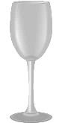
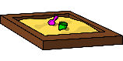
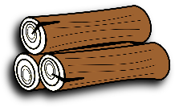
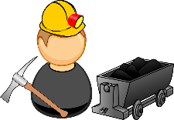
EEPING COOL
Solids, liquids and gases are called the three states of matter. Materials can be changed from one state to another by heating or cooling.

Heating
- If ice (solid) is heated, it changes to water (liquid). This change is called melting.
- Water (liquid) can change to water vapour (gas). This is called evaporation.
- If water (liquid) is heated until it boils, it changes to water vapour (gas) very quickly. Water boils at 100°C.

Cooling
- If water vapour (gas) is cooled, it changes to water (liquid). This change is called condensing.
- If water (liquid) is cooled, it changes to ice (solid). This change is called freezing. Water freezes at 0°C.
CHANGING STATE
MAN-MADE
NATURAL
. Heat proud
States of Matter
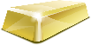
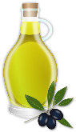
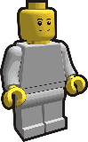
Three states of matter
GAS: particles far apart and randomly arranged / move around
LIQUID: particles close but randomly arranged / move around
SOLID: particles very close together / vibrate around a fixed position


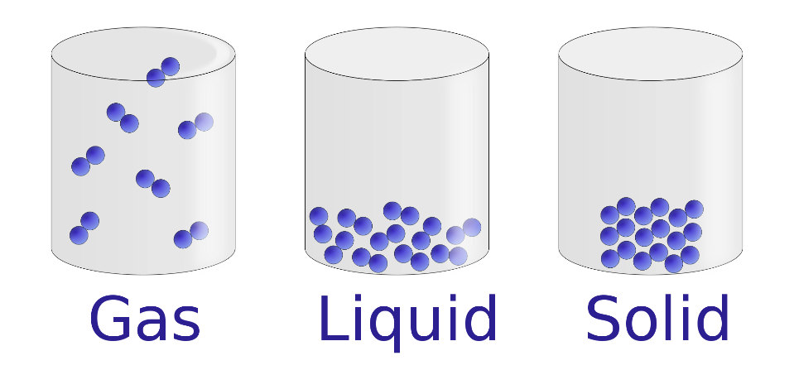
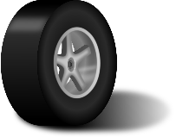

FREEZING
CONDENSATION
Examples
Ice
Wood
Glass
Diamond

MELTING
EVAPORATION

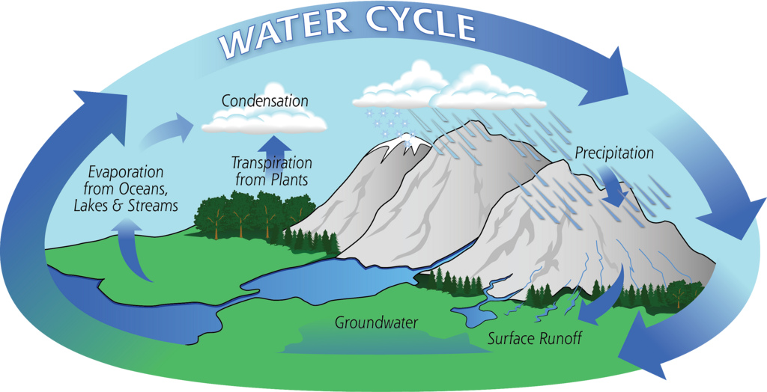
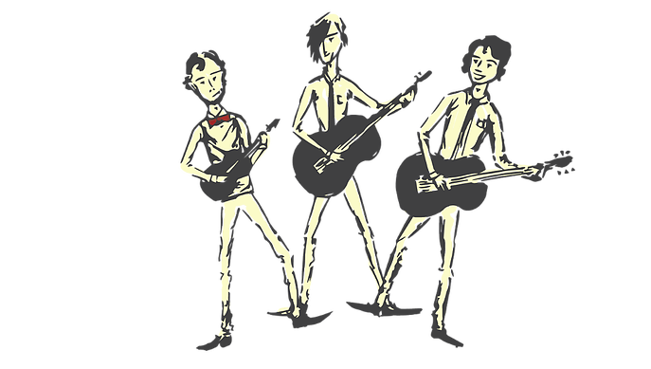
FEATURES

- Solids hold their shape. (Salt, sand and sugar are tiny solids so they pour like a liquid but they pile up and are nit wet.)

- Liquids form a pool not a pile!

- Gases escape from an unsealed container and fill the entire volume of space.
Examples
Water
Milk
Washing up liquid

Examples
Steam (water vapour)
Hydrogen
Carbon Dioxide
Oxygen

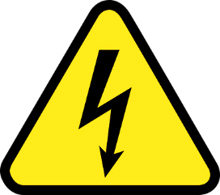
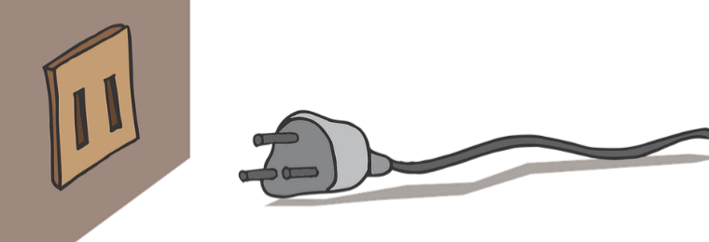
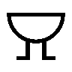
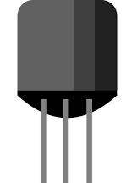
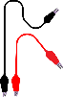
SWITCH
BATTERY/CELL
DANGER! HIGH VOLTAGE!
Electricity is everywhere so always be safe. Be careful of mains switches, open sockets and any signs to do with electricity. The human body is 80% water so it conducts electricity. If someone has had a shock always turn the electricity off first, then call for help!

WIRES

