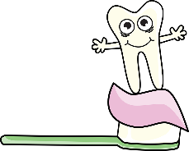
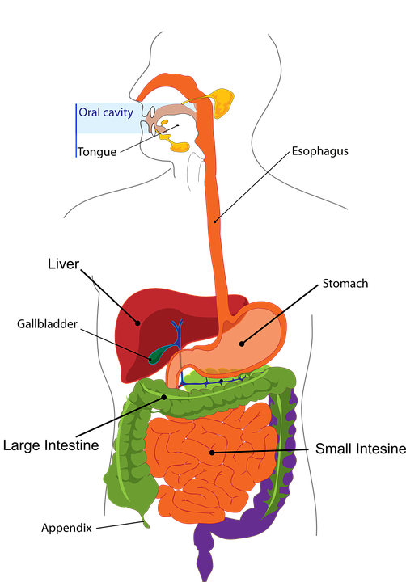
Parts of the Tooth
TOOTH DECAY
Colon
The Digestive System and Teeth
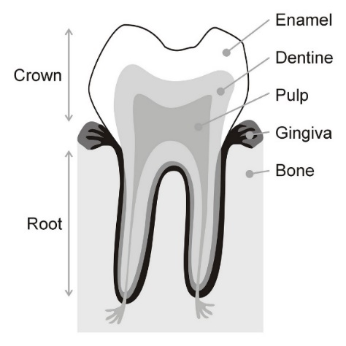
1.) Tooth decay is the destruction of your tooth enamel

2.) It can be a problem for children, teens and adults.

3.) Plaque, a sticky film of bacteria, constantly forms on your teeth.

4.) When you eat or drink foods containing sugars, the bacteria in plaque produce acids that attack tooth enamel.

5.) Tooth ache and bad breath are symptoms of tooth decay.
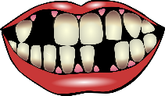
Mouth – Where food first enters the body. It is chewed and mixed with saliva, then swallowed.

Teeth – Used to break food into smaller pieces making it easier to swallow.

Oesophagus – Tube of muscle which connects the mouth to the stomach.

Stomach – Food is mixed with stomach acid
and broken down to form a liquid.

Oesophagus
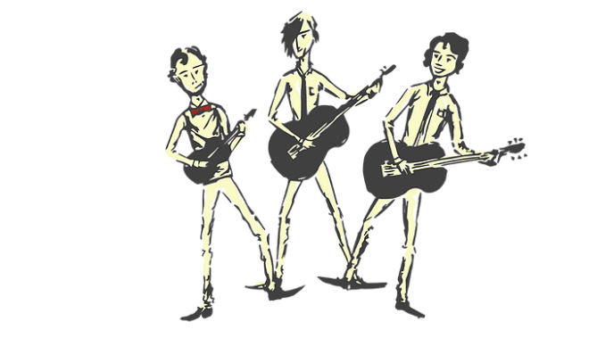
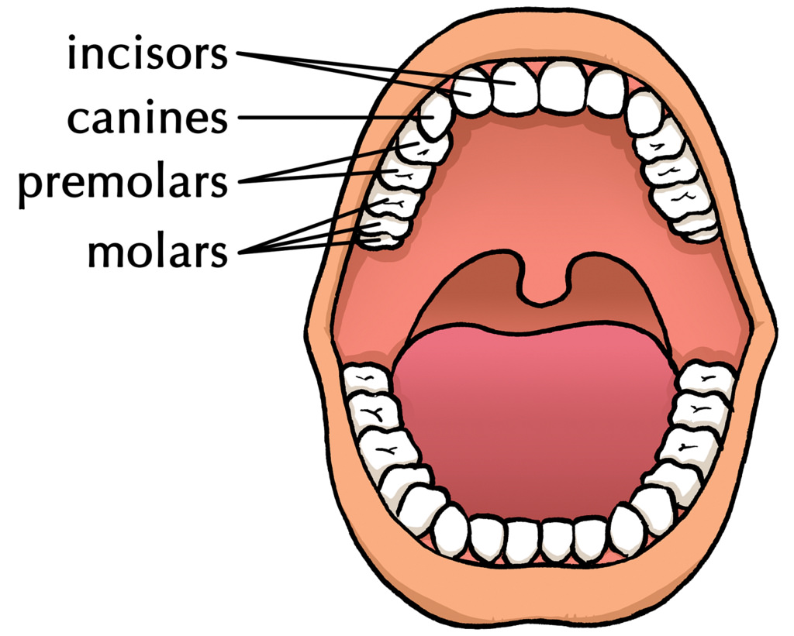
Intestines – Liquid from the stomach passes into the small and large intestines. This is where nutrients and water we need is passed into the blood stream and transported around our body.

INCISORS – At the front of the mouth and used for biting
CANINES – Sharpest teeth. Next to incisors and used for tearing. Sharp and pointed in predators for killing prey.
PREMOLARS – Flat, wide and used for chewing towards the back of the mouth.
MOLARS – At the back of the mouth. Used for chewing and grinding food. Wide and flat in shape, including wisdom teeth at the back which appear in adulthood.
Rectum – Any waste we do not need is stored here until it is ready to leave the body.

Enamel: The visible part of the tooth. It is harder than bone and protects the tooth.
Dentin: Found underneath the enamel and is similar to bone.
Pulp: Found in the centre of the tooth and is full of blood vessels and nerves. It supplies the tooth with nutrients.

