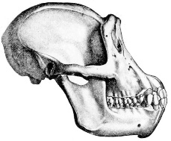
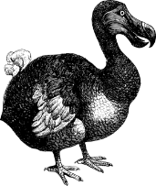
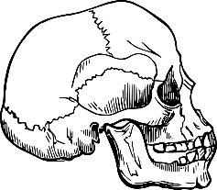
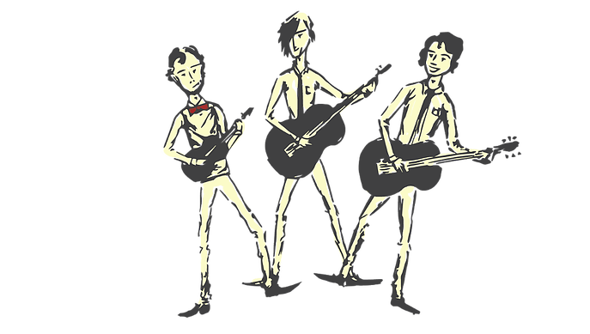
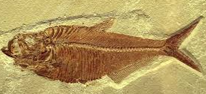
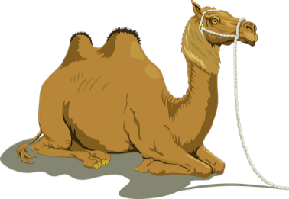
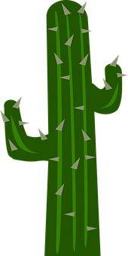
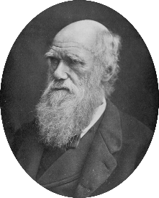
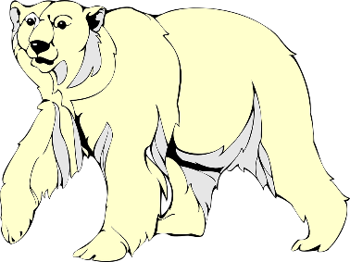
Evolution means change over time. It is the reason we have so many species on earth. It happens when there is competition to survive (natural selection) and through differences within a species caused by inheritance and mutations.

Inheritance is when something is passed on to the next generation. Offspring are not identical to their parents and some characteristics are inherited (carried in offspring from parents) and other differences are new in the offspring – these are called mutations
A cactus stores water to help keep it alive in the desert. It also has spikes to protect itself from attack.
A camel has humps of fat storage to use up for energy in the dry desert when there is a shortage of food.
Fossils are the remains of living things which inhabited the world millions of years ago. They are formed in sedimentary rock (sand, mud and pebbles squashed under layer, after layer over time) and plants/animals get trapped in these layers, revealing their shape.

HUMAN SKULL CHIMPANZE SKULL

When palaeontologists compare fossils to animals from today, they can see similarities and identify relationships between them. Since evolution of a species happens over such long periods of time, evidence is usually taken from fossils.
The dodo was a flightless bird from Mauritius which failed to adapt to its new environment. Humans arrived, hunted it and introduced other animals and so became extinct in 1681.
Evolution
THE DODO
Charles Darwin
(1809 – 1882)
1.) Charles Darwin is an English scientist best known for his theory of evolution.
2.) He was a geologist who went travelling in 1831 on the HMS Beagle.
3.) He saw many animals and plants and came up with the idea of natural selection (the strongest survive and evolve).
4.) His book ‘Origin of the Species’ was released in 1851 and was controversial because it went against the creation story in the Bible.

FOSSILS
A polar bear has adapted to camouflage itself against white snow/ice so it can hunt without being seen.
Question: What is adaptation?

Answer: A change in a plant or animal’s body to suit its location which can evolve over thousands of years in the most efficient way. If they don’t adapt, then they may not survive.

