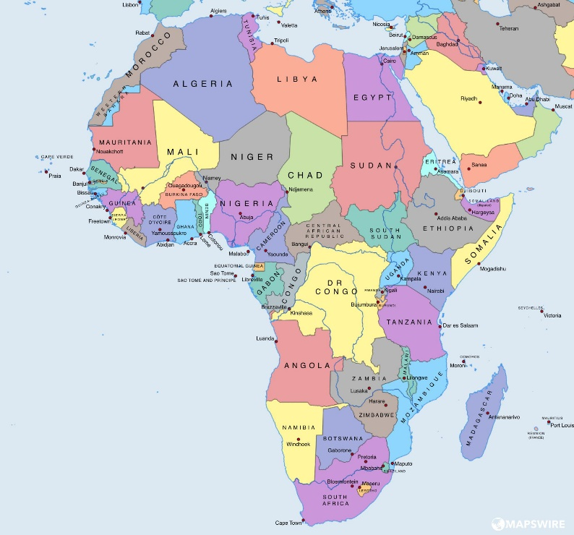
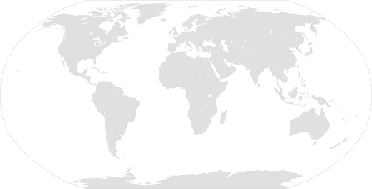

Fact Box
Africa is a continent made up of 54 different counties with Algeria being the largest in terms of area (2.4 million km²).
AFRICA
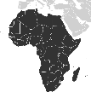
Key Vocabulary
cash crop | exported crops such as coffee, sugar, rubber and tea
cricket | South Africa are one of the world’s best teams
desertification | when fertile land becomes desert
drought | very low rainfall leading to water shortages
equator | Gabon, D.R. Congo, Uganda, Kenya and Somalia are on the equator, which is a line separating the northern and southern hemispheres of Earth.
Fair Trade | designed to help producers in developing countries achieve better trading conditions
Kalahari Desert | dry savannah covering Botswana in the south
Lake Victoria | source of the River Nile in eastern Africa
plateau | area of highland, raised above the surrounding area
safari | to observe/hunt animals in their natural habitat
savannah | woodland /grassland ecosystem with spaced out trees
subsistence farming | farmers grow food crops to feed themselves and their families, widely used in Africa
Table Mountain | flat-topped mountain overlooking Cape Town in South Africa and a tourist attraction
valley | low area of land between hills/mountains
Physical Features
Sahara Desert  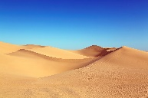 | This used to be a lush region with many plants/animals but dried out 4000 years ago. It covers 3.6million km² and is one of the hottest places on Earth (up to 46°C) but often below freezing at night. Known for sand dunes and salt flats.
Congo Basin  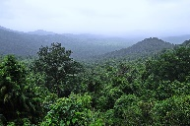 | The Congo rainforest in central Africa contains one of the longest rivers in the world, the Congo River. The tropical rainforest is home to a diverse range of plants and animals.
Atlas Mountains | The Atlas Mountains are a mountain range in northwest Africa. They run 2,410km from the Atlantic coast of Morocco to northeast Tunisia. They are not all joined and are separated by large areas of land called plateaus.
Great Rift Valley | Stretches from the Middle East in the north to Mozambique in the south and is geologically active featuring volcanoes, hot springs, geysers and frequent earthquakes.
Human Features
Deforestation  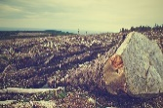 | The leading cause of deforestation in Africa is due to large numbers of developing countries relying heavily on wood fuel, the major energy source for cooking and heating. This occurs in Sub-Saharan areas.
Poaching  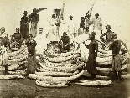 | Illegal poaching and trade of endangered animals has been a huge issue in Africa for many years. Elephant tusks (ivory) and rhino horns (hair) are removed after killing the animal and then sold for huge prices.
Famine and Poverty  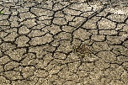 | 27 of the world’s poorest 28 countries live in Sub-Saharan Africa where there is a lack of access to safe water and sanitation. This has been the result of political instability, conflicts, climate change and man-made causes.
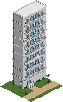
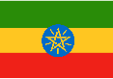
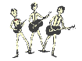
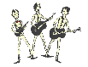
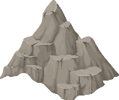
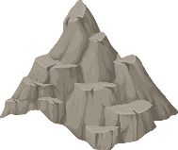
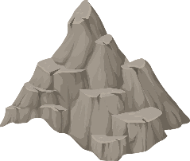
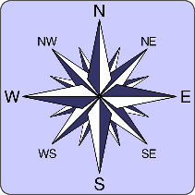
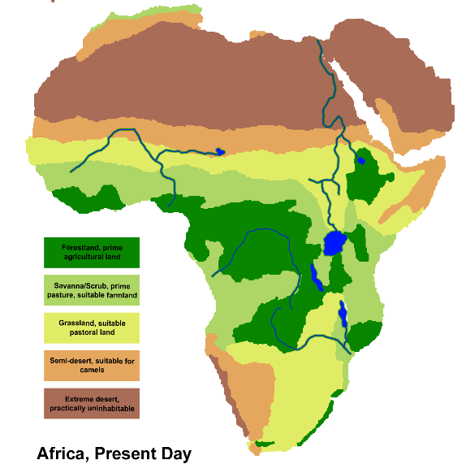
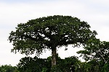
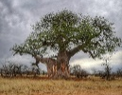
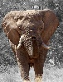
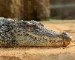
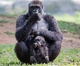
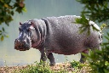
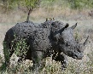
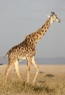
Examples: giraffes, rhinoceros, lions, hippopotamuses, gorillas, crocodiles and elephants (also – zebras, antelopes and cheetahs).
Great Rift Valley
Atlas Mountains
Congo
Basin
Sahara Desert
Baobab tree Acacia tree Kapok tree Red hot poker elephant grass
Longest Rivers

Nile – 6650km
(Egypt/Sudan)

Congo – 4700km
(D.R. Congo)

Niger – 4180km (Nigeria/Niger/Mali/Benin/Guinea)

Tallest Mountains

Mt Kilimanjaro Mt Kenya Mawenzi Peak
(Tanzania) (Kenya) (Tanzania)
5895m 5199m 5149m
Largest
Populations

Nigeria
(201 million people)

Ethiopia
(110 million people)

Egypt
(101 million people)
Fauna (animals)

Flora (plants)

© Mr A, Mr C and Mr D Present - 2019

