

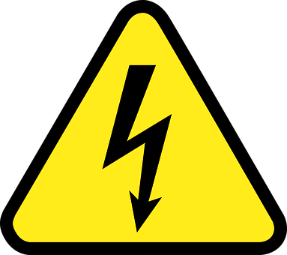
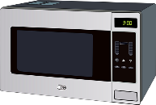
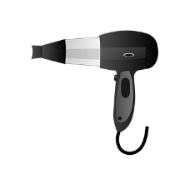
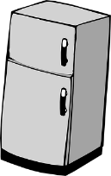
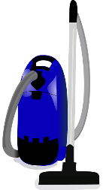
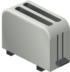
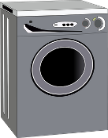



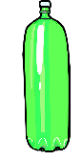



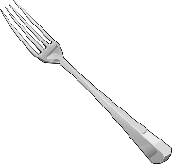
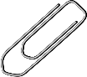


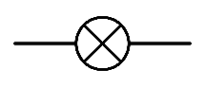
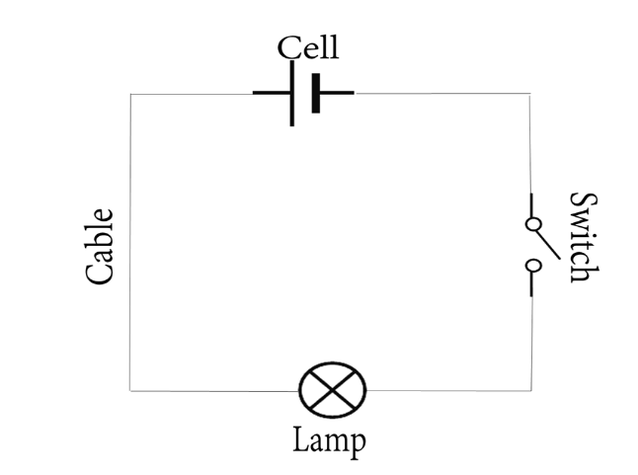
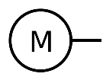
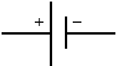

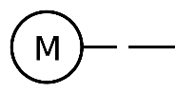

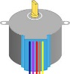


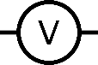
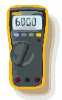


Current: this is the amount of electricity flowing through the circuit (a flow of electrons moving in a loop in the circuit). It is measured in amps.

Voltage: is the difference in electrical energy between two parts of a circuit. It is measured in volts. The bigger the voltage, the bigger the current.

This circuit will not work because the switch is open.
A circuit must be complete to work. It must also always have a battery/cell.
VOLTMETER
BATTERY/
CELL
BUZZER
SWITCH
DANGER! HIGH VOLTAGE!
Electricity is everywhere so always be safe. Be careful of mains switches, open sockets and any signs to do with electricity. The human body is 80% water so it conducts electricity. If someone has had a shock always turn the electricity off first, then call for help!
Electricity
1.) If you make the wires longer, the bulb will get dimmer. This is because there is more resistance.
2.) If you add more bulbs, the bulbs get dimmer. This is because there is also more resistance.
3.) If you add more batteries, the bulbs will get brighter. This is because there is less resistance and a greater current.

COMMON APPLIANCES
Wire
BULB
An electrical conductor lets electricity pass through. They are often metals but it also includes water.

An electrical insulator does not let electricity pass through.

MOTOR
WIRES

