

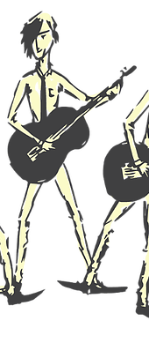
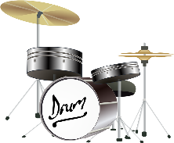

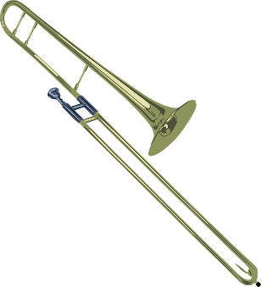
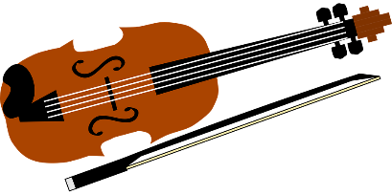
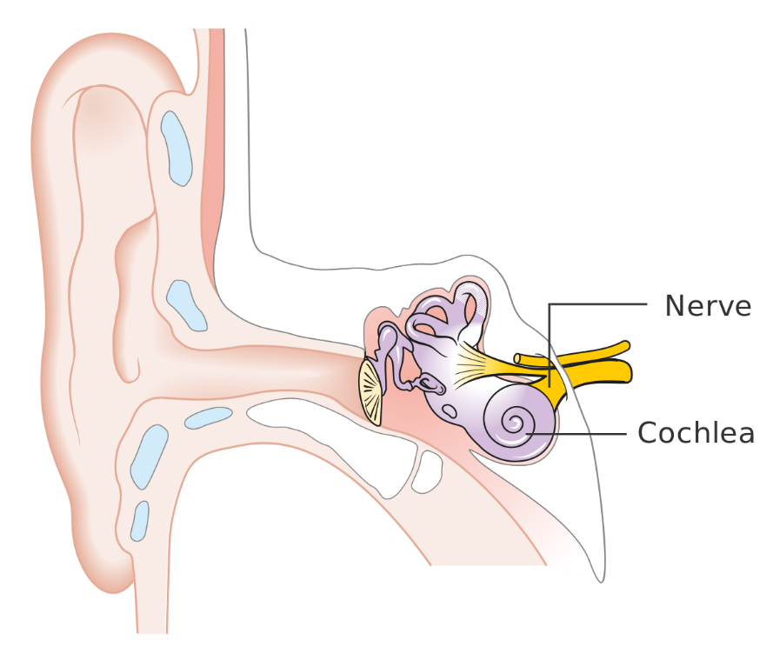
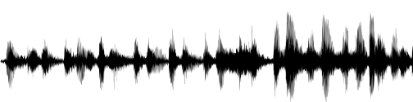
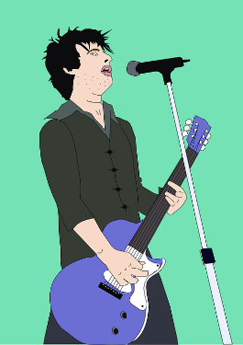
DID YOU KNOW?
Soundproofing is when a material is used to absorb loud sounds. Recording studios or night clubs might use them to stop sound escaping the room! Soft, spongey or pliable material is often best for this.
Sound travels better through some materials than others. It travels very well through metal pipes for example.

The louder the volume, the bigger the vibrations. The size of the vibration is called the amplitude. Quieter volumes have smaller amplitudes and louder sounds have larger amplitudes.

Sounds travel in a wave. The vibrations make air particles closes to the object vibrate, which then passes the vibrations to the particle next to it and so on – like dominoes
falling!
Sound vibrations can travel through different materials:

SOLIDS: metals, stone, wood
LIQUIDS: water
GASES: air

Outer Ear
Middle ear bones which include the hammer, anvil and stirrup. (The smallest bones in the human body!)

sends electrical signals to the brain.
DID YOU KNOW? Sounds get fainter (quieter) as the distance from the sound source increases.

PITCH
The pitch of a sound is how high or how low it sounds. A high pitch has a high sound and a low pitch has a low sound.

Stringed Instruments
Tighter, thinner or shorter strings make higher pitches. Faster vibrations make pitches high and slower vibrations make pitches low.

Wind Instruments
The column of air inside the instrument causes it to vibrate. Shortening this makes a higher sound, lengthening it makes a lower sound.

Percussion Instruments
The surface is struck and it therefore vibrates. Smaller instruments have higher sounds (smaller keys of a xylophone, hand bells etc.). The tighter or thinner the skin on a drum, the higher the pitch.

contains thousands of tiny hair cells which change the vibrations to electrical signals.
Ear drum which passes vibrations to the middle ear bones.
VIBRATIONS
Sound is made when an object vibrates and therefore causes the air around it to vibrate too. These vibrations are carried to your ear for you to hear them.

Sound

