Timeline
6000 B.C. | 5000 B.C. | 4500 B.C. | 3500 B.C. | 3000 B.C. | 2500 B.C. | 1500 B.C. | 1325 B.C. | 332 B.C. | 30 B.C.
People settle near the River Nile | Farmed wheat, barley and cattle | Use of sails for the first time | First use of hieroglyphics | Buildings of mud brick | Sphinx and Giza Pyramids | Valley of the Kings tombs built | King Tutankhamun buried | Alexander the Great rules | Death of Cleopatra
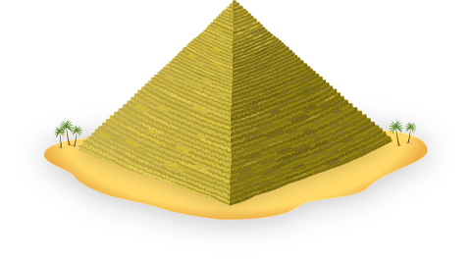
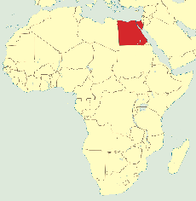
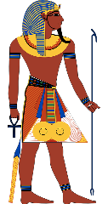
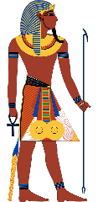
Egypt
(Africa)
Ancient Egyptians
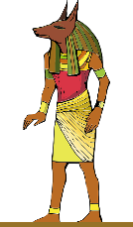
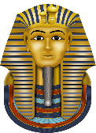

Gods
Amun – King of gods (head of a ram).
Anubis - God of mummification and priests often wore masks of Anubis during ceremonies (head of a jackal).
Bast – Goddess of protection and of household entertainment (head of a cat).
Sekmet – God of war and battle (head of a lion).
Horus – God of the sky (head of a falcon)

Afterlife
Ancient Egyptians believed that when they died, they would make a journey to another world where they would lead a new life. They would need all the things they had used when they were alive, so families would put those things in their graves. Egyptians paid vast amounts of money to have their bodies properly preserved. Those who were poor were buried in the sand whilst the rich were buried in a tomb.

Farming
Egyptians grew many crops, the most important being grain used to make bread, porridge and beer. They also grew vegetables and used irrigation to their advantage.

Famous Figures

King Tutankhamun (1341 B.C)
Known for his intact tomb discovered
in the Valley of Kings in 1922 by
Howard Carter (English archaeologist). Known now simply as ‘King Tut’, he took the throne aged 9 and died aged 19. His tomb was filled with precious jewellery, artefacts, gold, a mural of his journey to the afterlife and his now famous death mask and sarcophagus.

Ramses III (1155 B.C.)
Best known for defending his country in three great wars, twice against the advancing Libyans and once against the Sea People.

Cleopatra VII (69 B.C.)
She reigned as the queen of Egypt and inspired a Shakespeare play and several movies. She was part of the Macedonian dynasty and became romantically involved with Roman leaders Julius Caesar and Mark Anthony. In a male dominated society, her political ambition and power led to her legacy.

General Knowledge
 | Key Vocabulary
canopic jar | Jars with intestines, stomach, lungs and liver - all of which were thought to be needed in the afterlife.
cartouche | An oval containing hieroglyphics with a horizontal line underneath indicating a royal name.
hieroglyphics | A writing system where picture symbols stood for meanings or sounds. It meant ‘sacred carving’.
irrigation | Using the Nile, Egyptians would use annual flooding to channel water to dry areas to helping crops grow.
mummy | A body prepared for burial according to ancient Egyptian practice.
sarcophagus | A stone coffin adorned with a sculpture or inscription containing a mummy.
scarab | The use of the common scarab beetle was often used as a symbol for rebirth.
tomb | A chamber or vault to protect the dead, the most elaborate built within pyramids or underground.
papyrus | A type of plant grown in abundance in ancient Egypt turned into a paper-like material for writing.
pyramids | Over 130 giant pyramids were created as tombs for pharaohs, mostly built west of the River Nile.
The River Nile is about 6,670 km (4,160 miles) in length and is the longest river in Africa and in the world. Fertile soil along the banks of the river were used to produce food for themselves and their animals.
The Battle of Britain, between the German Luftwaffe and the Royal Air Force, was the first ever battle to be fought only in the air (known as dog fighting). It was made up of lots of air battles that lasted from 10 July-31 October 1940.

