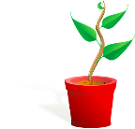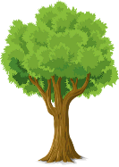

**PARTS OF A PLANT**

**FLOWERS**

**The flowers are often brightly coloured and smell to attract insects. Insects help with the plants reproduction through pollination.**

**LEAVES**

The **leaves** use light from the sun, along with carbon dioxide from the air and water to make food for the plant. This process is called photosynthesis.

**STEM / TRUNK**

The **stem** carries water and nutrients to different parts of the plant. They keep the plant upright.

**ROOTS**

The **roots** of a plant take up water and nutrients from the soil. The roots also keep the plant steady and upright in the soil; they "anchor" the plant.

**What does a plant need to grow?**

Plants

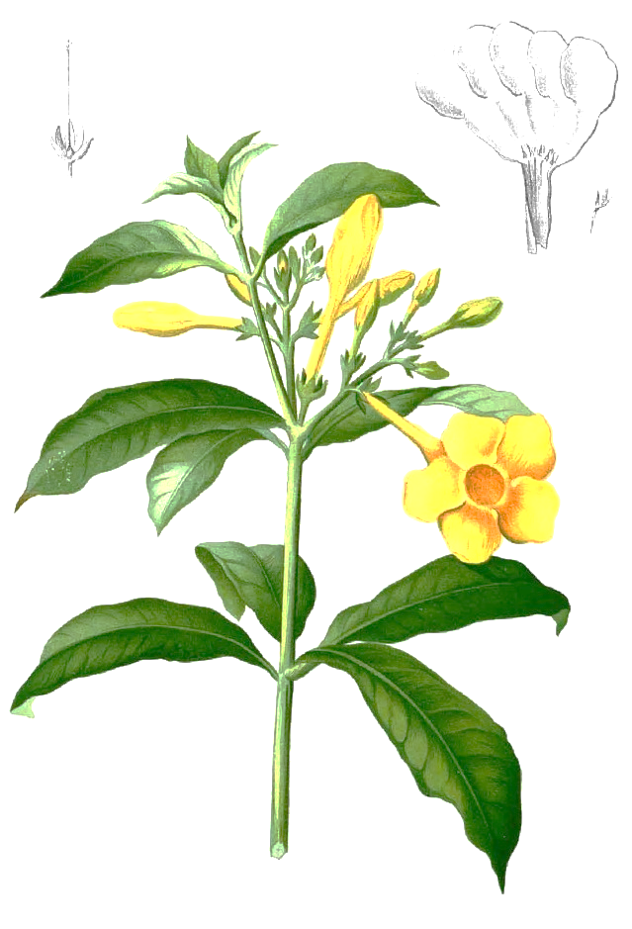

light

Smaller plants find it hard to survive when larger plants take up space. They block out sunlight and take nutrients and water from the soil.

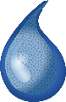

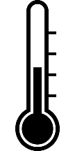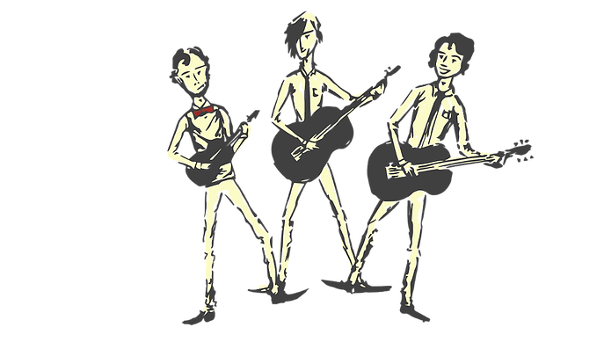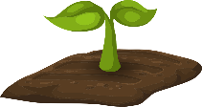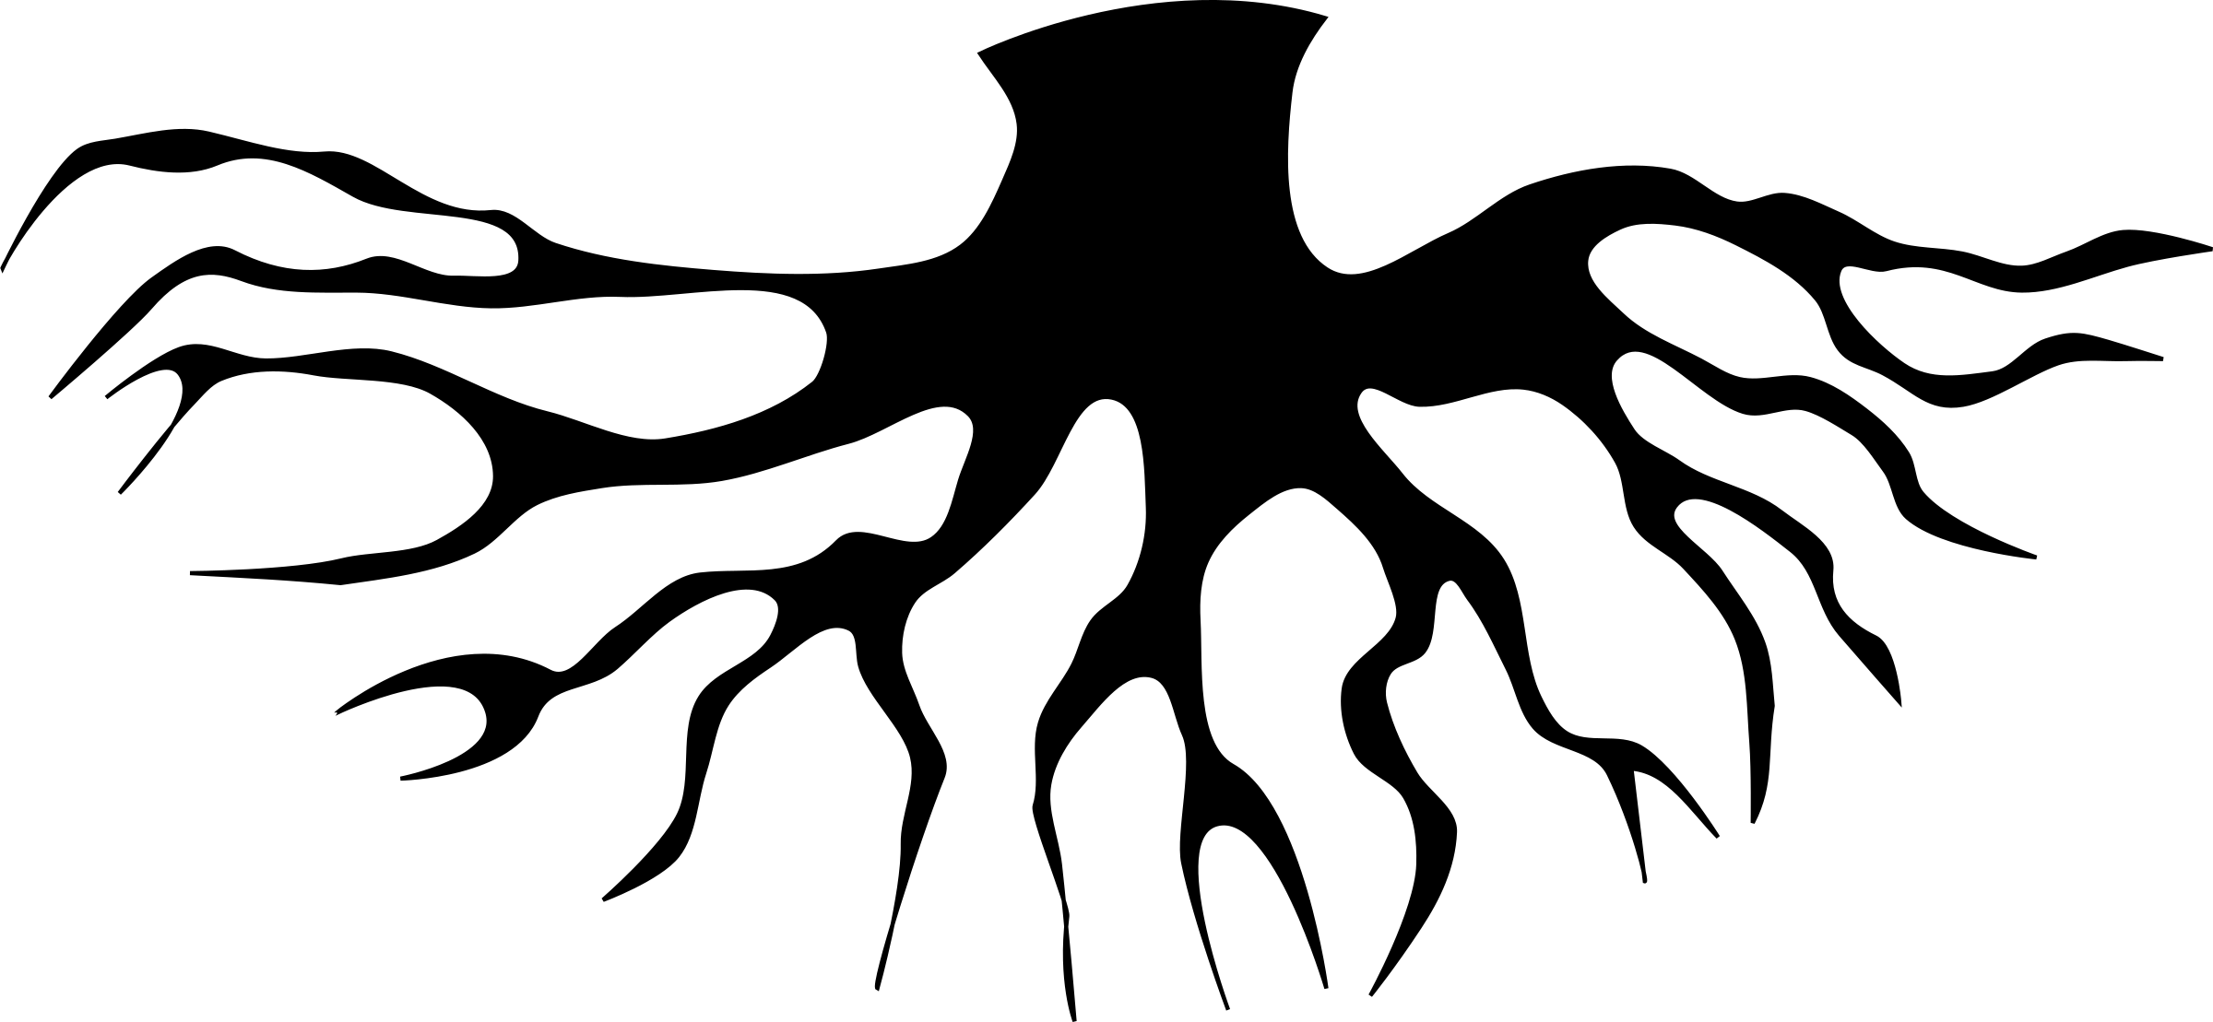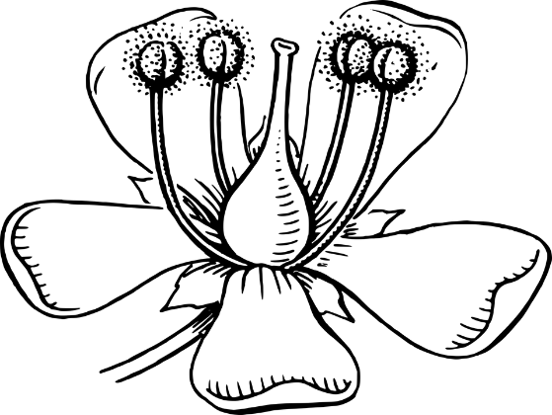

water

filament

stigma

anther

**PARTS OF A FLOWER**

nutrients

warmth

stem

leaves

flowers

Not all plants produce flowers. These non-flowering plants, such as Ferns and mosses. They grow from spores instead of seeds. Non-flowering plants as well as flowering plants make their own food through photosynthesis.

**PLANT REPRODUCTION**

**Pollination -** Pollen is carried by insects or blown by the wind from one flower to another. This process is called **pollination**.

**Fertilisation -** Pollen reaches the carpel of the new flower. Pollen then travels to the ovary where it fertilises egg cells (ovules) to make seeds. This process is called **fertilisation**.

**Seed Dispersal -** The seeds are scattered by animals or the wind. This process is called **dispersal**. Some of the seeds will grow into new plants.

air

roots

style

ovary

sepal

stem

petal